Errata – Population Distribution

Large Cities

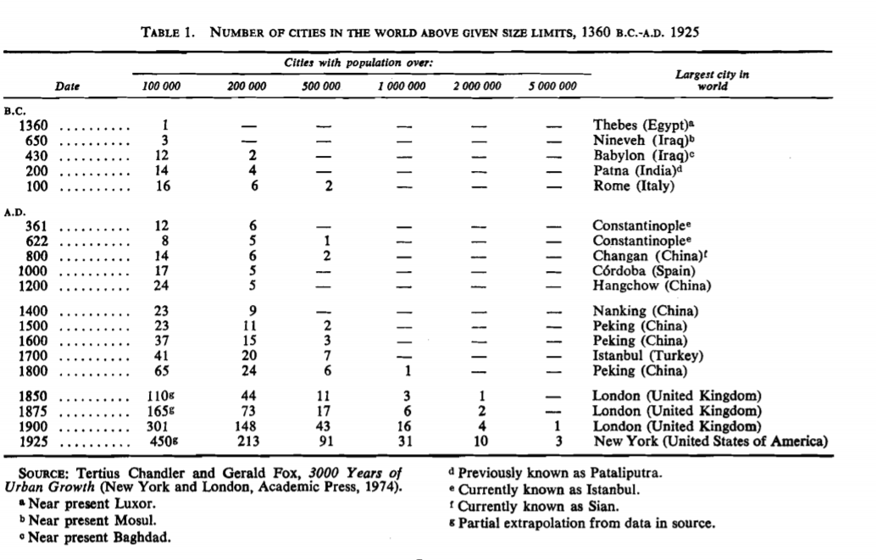

Urban vs Rural Population
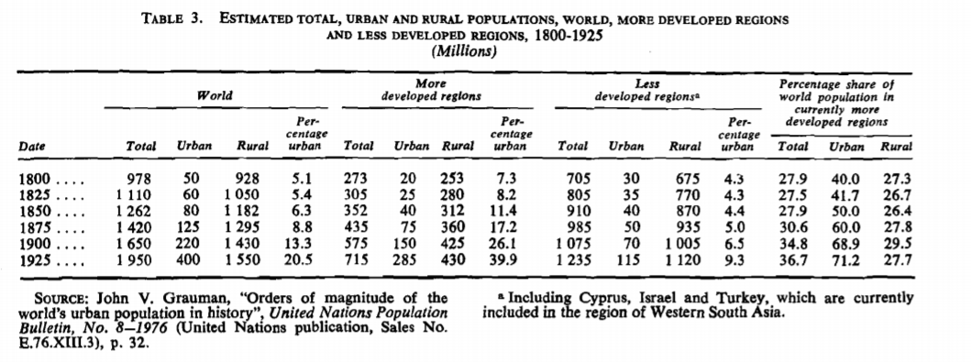
Fertility rate to crude birth rate
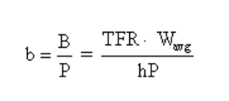

where b is CBR, TFR is total fertility rate, W_avg is average age of woman (in non-Die Off-tolerant society; replace with average age of childbering woman maybe for ancient society), h is number of years in an age cohort (total childbering years maybe), P is total population.

